DATE: 12.07.2019
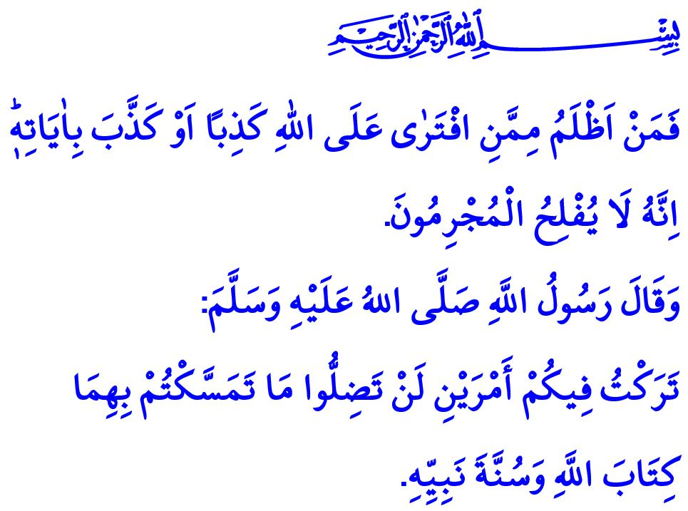
COMMEMORATION OF THE JULY 15 AND COMPREHENSION OF THE BETRAYAL
Honorable Muslims!
The Almighty Allah (swt) states in the verse I have quoted, “Who does more wrong than those who fabricate lies against Allah, or deny His revelations? Indeed, the wicked will never succeed.”
In this respect, the Prophet Muhammad (saw) said, “I leave behind me two things, and if you follow these you will never go astray. They are the Qur'an and the Sunnah.”
Dear Believers!
Our nation came safely through an existential challenge three years ago. The terrorist organization FETO, which has, under the guise of serving for Allah's (swt) cause, exploited the resources and values of our nation for years, finally attacked the independence and future existence of our nation. However, our nation, which has throughout the history overcome countless betrayals thanks to its resoluteness, courage, and self-sacrificing nature, did not let this invasion attempt succeed, too, with the help of Allah (swt). Today, once again and always, we as a nation express our endless gratefulness to the Almighty Allah (swt) for helping us.
Honorable Muslims!
Those people who tried to demolish our nation's parliament and drag our young people and future generations to captivity on the July 15 did all of it under the veil of being religious. While they appeared to teach about and call to the religion of Islam, and to be in the service of the ummah, all that they did actually was to pave the way for corruption. Such corruptors are referred to in the Holy Qur'an as follows, “When they are told, “Do not spread corruption on the Earth," they reply, “We are only peace-makers!” Indeed, it is they who are the corruptors, but they fail to perceive it.”
Honorable Believers!
Could there be a worse danger than spreading tumult, sedition and corruption disguised as peacemaking?
This is referred to in the words of the Prophet Muhammad (saw) as follows, “Whoever deceives us is not one of us.” Then, could there be a more serious crime than deceit, invasion, and exploitation through the instrumentality of the religion?
Let us not forget that the terrorist organization FETO, which used the methods of disguising itself, sailing under false colors, hypocrisy, lies, threats, and blackmailing to remain standing, has never been a religious organization.
The FETO is a terrorist organization that tried to create a so-called moderate Islam through dreams, mysteries, and insidious plots.
Honorable Believers!
No knowledge in contradiction of the Qur'an and the Sunnah is of religious value. All understandings and approaches are deviant other than the middle-of-the-road approach and the straight path (mustaqim) followed by the majority of Muslims since the time of the Prophet's Companions.
According to Islam, there is no authority “innocence and incontrovertible” other than the Prophet Muhammad. Muslims, therefore, cannot entrust their reasoning, will, and disposition to other people blindly.
Muslims are but brothers. Damaging the unity of the ummah with arrogance, hypocrisy, corruption, and slander, and giving way to discord cannot be accepted.
Dear Muslims!
While we remember the July 15, we should comprehend the betrayal, and bring to mind our responsibilities. We should lead a life guided by the Holy Qur'an and the Sunnah of the Prophet Muhammad (saw). We should not give opportunity for those who abuse the religion for their personal interests. We should protect the Anatolian wisdom that has been accumulating on this land for centuries and is the power to keep our religious life standing.
We should be awake and alert against those who aim to exploit our religion, language, ethnicity, and innate richness, in order not to relive the bitter experience on the July 15. We should together stand against the acts of hypocrisy by those who want to drag our nation into sedition and corruption. We should regard the property of each other as our own property, the rights of each other as our own rights, and the honor and dignity of each other as our own honor and dignity. We should not behave in such a way as to cause our peace, trust, and brotherhood to be damaged. We should make no compromise on our unity and solidarity.
We should pay attention that our children learn the authentic religious knowledge through true methods and techniques from competent persons for the future existence of our state and nation, and for the well-being of the Prophet Muhammad's (saw) ummah. We should be careful about the people to whom we entrust our children, as well as with whom they are friends, where they spend their time, and what they learn about the religion.
On this occasion of the anniversary of the July 15, we remember, wishing Allah's mercy upon and deeply felt gratefulness for, our martyrs who sacrificed their lives for the cause of the homeland and our veterans who proudly carry their wounds like a liberty medal.

Yunus, 10/17.
Muvatta’, Qadar, 3.
Baqarah, 2/11-12.
Muslim, Iman, 164. General Directorate of Religious Services

